Proficiency in STEM fields is decreasing at a worrisome rate in the United States. In 2012 the Program for International Student Assessment (PISA) was given to 15 year old students across the world to compare academic proficiency between countries. The United States scored 23rd in math and 31st in science compared to 65 other industrialized countries, a worryingly low score[1].

There are two methods proposing to help increase STEM education proficiency, Process Oriented Guided Inquiry Learning (POGIL) and Engineering Design Process (EDP). POGIL is a student lead educational paradigm where teachers point students in the right direction and let them discover the lesson on their own through experimentation and research. At the end of each unit the topic is wrapped up by the teacher to ensure students have a clear understanding of the material [2]The A.R.C. robot would make a great teaching aid for a POGIL style environment. It could be used as the basis for a lesson plan in fluid power, control theory, electrical design, and many other lessons.

EDP is a learner-centered paradigm to teaching where the professor outlines a real world problem and asks students to come up with solutions based on topics covered in class. This is the type of learning typically seen in classes with laboratory time [3]. Due to the interdisciplinary nature of robotics the A.R.C. robot could be used in many introductory design applications. It could be used to enhance Electrical Engineering, Mechanical Engineering, Software Engineering, Controls, or even Fluid Power curricula. Not only could the robot and its subsystems be used to generate design problems, it’s also possible to use it as a research platform or as an example of a solution generated using the engineering design process.

# Bibliography

|  |  |
| --- | --- |
| [1] | S. Dillon, "In PISA, Top Scores from Shanghai Stun Experts," The New York Times, 7th December 2010. [Online]. Available: http://www.nytimes.com/2010/12/07/education/07education.html?pagewanted=1&_r=0. [Accessed 20 November 2014]. |
| [2] | POGIL, "POGIL | Home," POGIL, 2014. [Online]. Available: https://pogil.org. [Accessed 19 November 2014]. |
| [3] | J. H. T. O. T. C. Kristeb Billar, "Teaching STEM by Design," *Advances in Engineering Education,* vol. 4, no. 1, p. 21, 2014. |

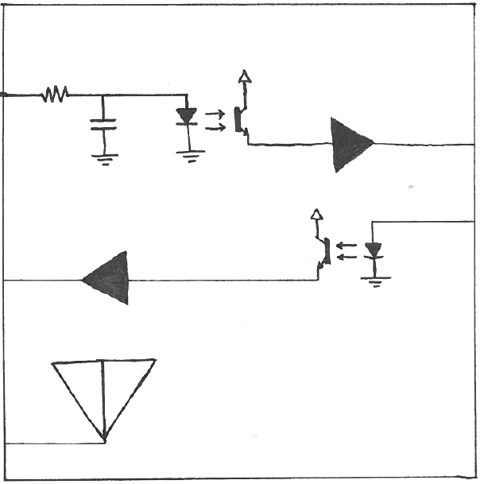

**Position Feedback Signal from Sensor**

**Feedback Signal to Microcontroller**

**Control Signal to Actuator**

**Amplifier**

**Radio Receiver**

**PWM Signal from Microcontroller**

**Low Pass Filter**

**Opto-isolator**